

**BIRDS 5 Project**

**EM Vibration Test Report**

Kyushu Institute of Technology

Laboratory of Lean Satellite Enterprises and In-orbit Experiments

|  |  |  |  |
| --- | --- | --- | --- |
| **Date** | **Version Number** | **Writer** | **Annotations** |
| 2021/10/27 | V1.0 | Victor Mukungunugwa | First Draft |
|  |  |  |  |
|  |  |  |  |
|  |  |  |  |
|  |  |  |  |

Table of Contents

1 Introduction 3

2 Referenced Documentation 3

3 Test Purpose 3

3.1 Overall Test Description 3

3.2 Success Criteria 3

4 Test article(s) 4

5 Test Facility Equipment 4

6 Acceleration measurement point 5

7 Test Description 5

7.1 Actual Test flow 5

7.2 Test set-up 6

7.3 Supporting analysis 6

7.4 Test condition 7

8 Test Schedule 9

9 Test Result 9

10 Acquired data 9

11 Discussion 9

12 Conclusion 9

13 Appendix 9

# Introduction

## 1.1 Applicable satellite

This test plan is applied to a vibration test for BIRDS 5(EM) satellite. The aim of the test is to demonstrate that the test article can withstand mechanical vibration when excited with acceleration levels induced by launch vehicles including HTV-X, Dragon and Cygnus.

## 1.2 Applicable Documentation

|  |  |  |
| --- | --- | --- |
| **Document number** | **Document description** | **Revision level or Release date** |
| JX-ESPC-101132-D | JEM Payload Accommodation Handbook; Small Satellite Deployment Interface Control Document | Vol 8. May, 2020 |
| Torque Chart | Maryland Metrics Torque Chart | Retrieved May, 2016  https://mdmetric.com/tech/torqcht1a.pdf |

## 1.3 Test Purpose

### Overall Test Description

The purpose of this test is to evaluate the impact of vibration by launch vehicle on BIRDS 5 CubeSat structure.

### 1.3.2 Success Criteria

The success of the vibration test will be determined based on the following criteria:

1. **Shift in Natural Frequency:**

A significant shift in natural frequency indicates workmanship failure (loose components on/in the structure). Any broken parts in the primary structure shall be judged as a failure in design.

1. **Torque Mark Shift:**

When observed visually, there should be no shift in torque marks on the screws on the test article after each test. Any shift in torque mark shows a workmanship failure in setting the required torque before testing

1. **Fracture Critical Parts:**

All external fasteners and fasteners holding the main structure shall not be loose after vibration.

Glass components (including solar cells, camera lens, filter and protected tempered glass for camera lens) shall not be broken after vibration.

1. **Deployable Components**

The deployable dipole Langmuir probes and antennas shall not deploy during vibration.

1. **Radio Interference**

Satellite shall not broadcast radio (CW) during vibration. Radio is set to CW frequency throughout the test to confirm no broadcast is received from satellite.

1. **Satellite Function**

Satellite functional test shall be conducted before and after vibration tests. Satellite should function the same after the vibration test as before the test.

# Test Preparation

## 2.1 Period

2021/10/13

## 2.2 Test Facility

Center for Nanosatellite Testing (CeNT)

Laboratory of Lean Satellite Enterprises and In-Orbit Experiments

Kyushu Institute of Technology

1-1 Sensui, Tobata, Kitakyushu, 804-8550 Fukuoka, Japan

## 2.3 Test Articles

The test article is BIRDS 5 (EM). The test sample is the one that installed BIRDS 5 satellite in a test POD. The test articles are indicated in Table 2.3-1.

**Table 2.3-1 Test articles**

|  |  |  |  |  |  |
| --- | --- | --- | --- | --- | --- |
|  | **Article name** | **Number** | **Manufacturer** | **Mass (kg)** | **Dimension (mm)** |
| 1 | BIRDS 5 EM 1U | 1 | Kyutech& HMD | - | 100 (L) x 100 (W) x 113 (H) |
| 2 | BIRDS 5 EM 2U | 1 | Kyutech & HMD | - | 100 (L) x 100 (W) x 226.5 (H) |
| 3 | 3U Pod | 1 | HMD | - | - |

|  |  |
| --- | --- |
|  |  |
| 1. BIRDS 5 EM (1U and 2U) 2. 3U POD |  |

**Figure 2.3-1 Test articles**

The outside drawing and the coordinates system of the test article and the test sample are shown in Figure 2.3-2 and Figure 2.3-3.

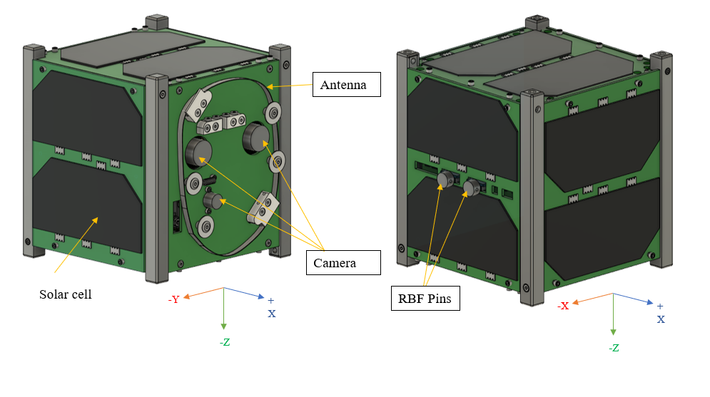

**Figure 2.3‑1 a: BIRDS 5 1U EM**

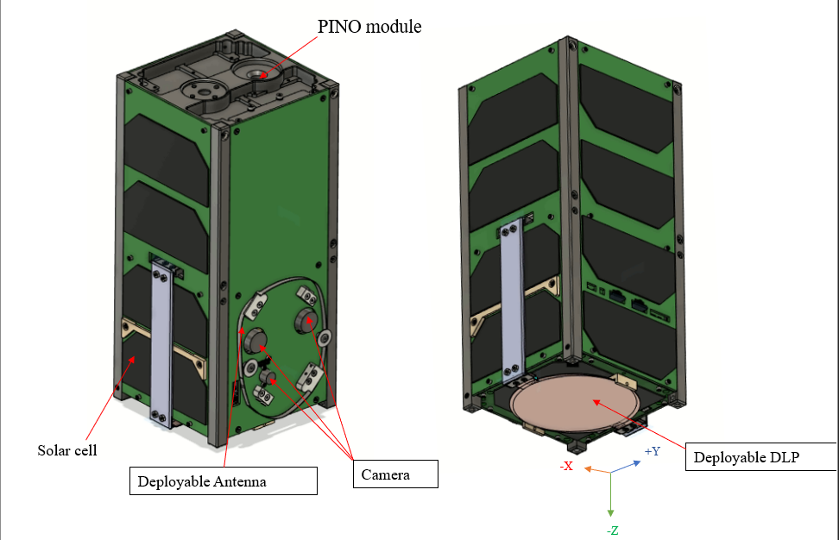

**Figure 2.3‑1 b: BIRDS 5 2U EM**

**Figure 2.3‑1 Outside drawing and coordinates system of test article**





**Figure 2.3‑3 Coordinates system of test sample**

## 2.4 Test Equipment

The test equipment used by this test is indicated in Table 2.4-1.

**Table 2.4-1 Vibration testing system specification**

|  |  |  |  |  |
| --- | --- | --- | --- | --- |
| **No.** | **Items** | **Specification** | | |
| 1 | Type | F-35000BD/LA36AP(made by EMIC) | | |
| 2 | Exciting Force | Sine | | 35.0 kN |
| Random | | 28.0 kN |
| Shock | | 87.5 kN |
| 3 | No-load maximum acceleration | Vertical | Sine | 1060.0 m/s2 |
| Shock | 1470.0 m/s2 (0-p) |
| Horizontal | Sine | 460.5 m/s2 |
| Shock | 1151.3 m/s2 (0-p) |
| 4 | Maximum loading mass | Vertical | | 400 kg |
| Horizontal | | 500 kg |
| 5 | Horizontal vibration table size | 50cm×50 cm | | |
| 6 | Power | 49.0 kVA | | |



**Figure 2.4-1 Vibration Test Machine**

The Figure 5-1 is an image of the vibration test machine used for the vibration test.

## 2.5 Test Tools

The test jig and tool used by this test are indicated in Table 2.5-1. Torque values used in this test are shown in Table 2.5-2.

**Table2.5-1 Jig and Tools**

|  |  |  |  |  |  |
| --- | --- | --- | --- | --- | --- |
| No. | Name | Type | Manufacture | Quantity | Note |
| 1 | JIG | B-2 | Kyutech | 1 |  |
| 2 | Wrench torque | 30-140Nm | Tohnichi | 1 |  |
| 3 | Wrench torque | 2-10Nm | Tohnichi | 1 |  |
| 4 | Wrench driver | 0.2-1.2Nm | Tohnichi | 1 |  |
| 5 | Kapton tape | - | - | 1 |  |
| 6 | Tape | - | - | 1 |  |
| 7 | Instant glue | - | - | 1 |  |
| 8 | Alcohol | Isopropyl | - | 1 |  |
| 9 | Paper cloth | JK wiper | - | 1 |  |
| 10 | Pen | - | - | 1 |  |

**Table 2.5-2 Torque list**

|  |  |  |
| --- | --- | --- |
| Bolt Size | Torque[Nm] | Position |
| M12 | 90 | Jig |
| M6 | 9.2 | POD-Jig |
| M3 | 1.14 | POD |

## 2.6 Measurement Instrument

The measurement instrument used by this test is indicated in Table 2.6-1.

**Table 2.6‑1　Measurement instrument**

|  |  |  |  |  |  |
| --- | --- | --- | --- | --- | --- |
| No. | Name | Type | Manufacture | Quantity | Note |
| 1 | Accelerometer | HM | EMIC | 4 | For control and monitor |
| 2 | Accelerometer | 2222C | Endevco | 11 | For monitor |
| 3 | Accelerometer | M357B06 | TOYO Tech. | 3 | For monitor |
| 4 | Charge Amp. | 4035 | SHOWA | 3 |  |
| 5 | DAQ system | 9215 | National Instrument | 1 |  |
| 6 | Analysis device | PC | - | 1 |  |
| 7 | Coaxial cable for accelerometer | - | - | 16 |  |
| 8 | Coaxial cable for connect between DAQ and Amp | - | - | 16 |  |

## 2.7 Acceleration measurement point

Acceleration measurement points are shown in Figures 2.7-1 and 2.7-2.. The accelerometers position and channel number designation are indicated in Table 2.7-1.

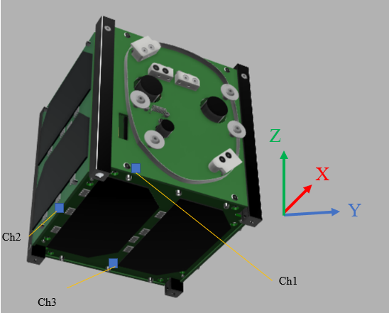 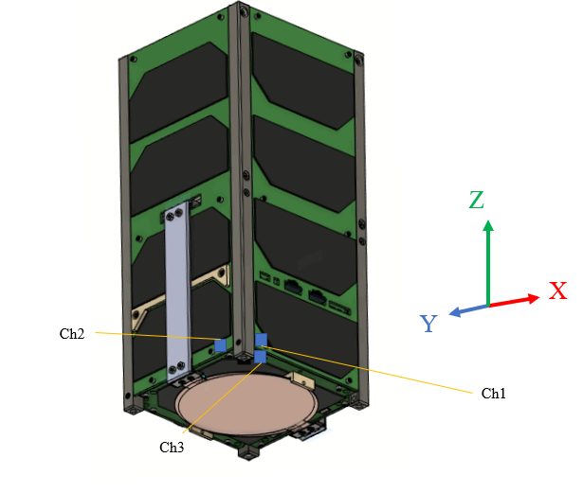

**Figure 2.7-2 Sensor Locations on External Panels**

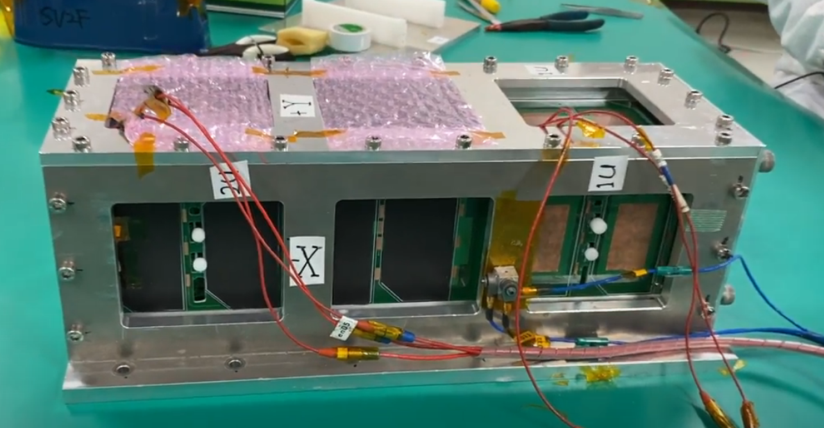

**Figure 2.7-3 Sensor connection on the POD**

**Table 2.7-1 Accelerometer position**

|  |  |  |  |  |
| --- | --- | --- | --- | --- |
| Ch. | Axis | Mounting position | Accelerometer number | Model |
| 1 | X | -X Panel (2U) | en 01 | 2222C |
| 2 | Y | +Y Panel (2U) | en 02 | 2222C |
| 3 | Z | -Z Panel (2U) | en 05 | 2222C |
| 4 | Y | +Y Panel (1U) | en 02 | 2222C |
| 5 | X | -X Panel (1U) | en 01 | 2222C |
| 6 | Z | +Z Panel (1U) | en 05 | 2222C |
| 7 | Y | POD | tt04 | M357B06 |
| 8 | X | POD | tt05 | M357B06 |
| 9 | Z | POD | tt06 | M357B06 |
| 10 |  |  |  |  |
| 11 |  |  |  |  |
| 12 | X | Control | EM13 | 731-B |
| 13 | X | Control | EM14 | 731-B |
| 14 |  |  |  |  |
| 15 | - | Jig(monitoring accelerometer) | EM12 | 731-B |
| 16 | - | Jig(monitoring accelerometer) | EM15 | 731-B |

TEMPERATURE 22OC

Humidity 57.7%

**Table 2.7-2 Charge amplifier setting**

|  |  |  |
| --- | --- | --- |
| **Ch.** | **Sensor** | **PC/G** |
| **1** | en 01 | 1.58 |
| **2** | en 02 | 1.12 |
| **3** | en 05 | 1.24 |
| **4** | tt01 | 4.34 |
| **5** | tt02 | 3.59 |
| **6** | tt03 | 4.75 |
| **7** | EM13 | 36.3 |
| **8** | EM11 | 37.5 |
|  | **CONTROL CENTER** |  |
| **2** | **EM12** | **3.824 [pC/(m/s2)]** |
| **3** | **EM15** | **3.552 [pC/(m/s2)]** |

# Test Description

## 3.1 General Condition

General conditions are as follows.

Temperature : 15°C - 30 °C

Humidity : 30 – 60 %

Atmosphere : Atmospheric pressure

Cleanness : Class 8

## 3.2 Test condition

The test shall consists of:

● Modal survey

**Table 3.2-1 Modal survey test table**

|  |  |  |  |
| --- | --- | --- | --- |
| **MODAL SURVEY** | | | |
| **Direction** | **Frequency [Hz]** | **Acceleration [Grms]** | **Time [min]** |
| X, Y, Z | 20~2000 | 0.5  (White Noise) | 1 |

● Random vibration test

The Random Acceleration Profile for each vehicle are shown in Figure 3.2-1 derived from maximum PSD values of HTV-X, Dragon and Cygnus launch vehicles as shown in Table 3.2-1. Test (Envelope) level is shown in Figure 3.2-2 and Table 3.2-3.



**Figure 3.2-1 QT Random Vibration Profile for HTV, Dragon and Cygnus**

*Refer: Random Vibration and Acceleration, Table 2.4.1-1, Pg.20, JX-ESPC-101132D



**Figure 3.2-2 QT Test (Envelope) Random Vibration Profile**

**Table 3.2-2 Random Vibration QT level of Each Launch Vehicle**

|  |  |  |  |  |  |
| --- | --- | --- | --- | --- | --- |
| **HTV-X** | | **SpX DRAGON** | | **NG Cygnus** | |
| **Freq. (Hz)** | **PSD (g2/Hz)** | **Freq. (Hz)** | **PSD (g2/Hz)** | **Freq. (Hz)** | **PSD (g2/Hz)** |
| 20 | 0.01 | 20 | 0.04 | 20 | 0.008 |
| 50 | 0.04 | 200 | 0.04 | 30 | 0.008 |
| 120 | 0.062 | 2000 | 0.002 | 70 | 0.03 |
| 230 | 0.062 |  |  | 150 | 0.03 |
| 1000 | 0.009 |  |  | 2000 | 0.0012 |
| 2000 | 0.0026 |  |  |  |  |
| Overall (grms) | 5.73 | Overall (grms) | 4.53 | Overall (grms) | 3.45 |

*Refer: Random Vibration and Acceleration, Table 2.4.1-1, Pg.20, JX-ESPC-101132D

**Table 3.2-3 Random Vibration QT level**

|  |  |
| --- | --- |
| **Envelope (QT)** | |
| **Freq. (Hz)** | **PSD (g2/Hz)** |
| 20 | 0.04 |
| 50 | 0.04 |
| 120 | 0.062 |
| 230 | 0.062 |
| 1000 | 0.009 |
| 2000 | 0.0026 |
| Overall (Grms) | 5.77 |
| Duration (s) | 120 |

● Sine burst test

Test level is shown in Table 3.2-4.

**Table 3.2-4. Sine Burst QT table**

|  |  |  |  |
| --- | --- | --- | --- |
| **SINE BURST QT** | | | |
| **Direction** | **Freq. [Hz]** | **QT** | |
|  | **Number of waves** | **Acceleration [G]** |
| Vertical axis (Y) | 10~40 | 10 or more | 11.25 |
| Horizontal axis (X, Z) | 10~40 | 11.25 |
| 11.25 |

*1 sec includes 10 waves or more.

● Test tolerance

Apart from modal survey, vibrations test tolerances are described below.

* 1. Sine Burst

・Acceleration: ±2%

* 1. Random vibrations

・Effective value: ±1.5dB

・Acceleration density: +3dB/-1dB

・Frequency: ±2% or above 1Hz

・Loading time: +10%/-0%

## 3.3 Actual Test flow

The test flow is shown in Figure 3.3-1.



**Figure 3.3-1 BIRDS 5 EM vibration test flow**

* These functional tests are performed independently of the vibration test.   
**Before modal survey, visual inspection was conducted.

## 3.4 Test set-up

The measurement configuration of the monitor acceleration and the output signal processing is shown in Figure 3.4‑1.



**Figure 3.4-1 Schematic of Test Equipmen**t

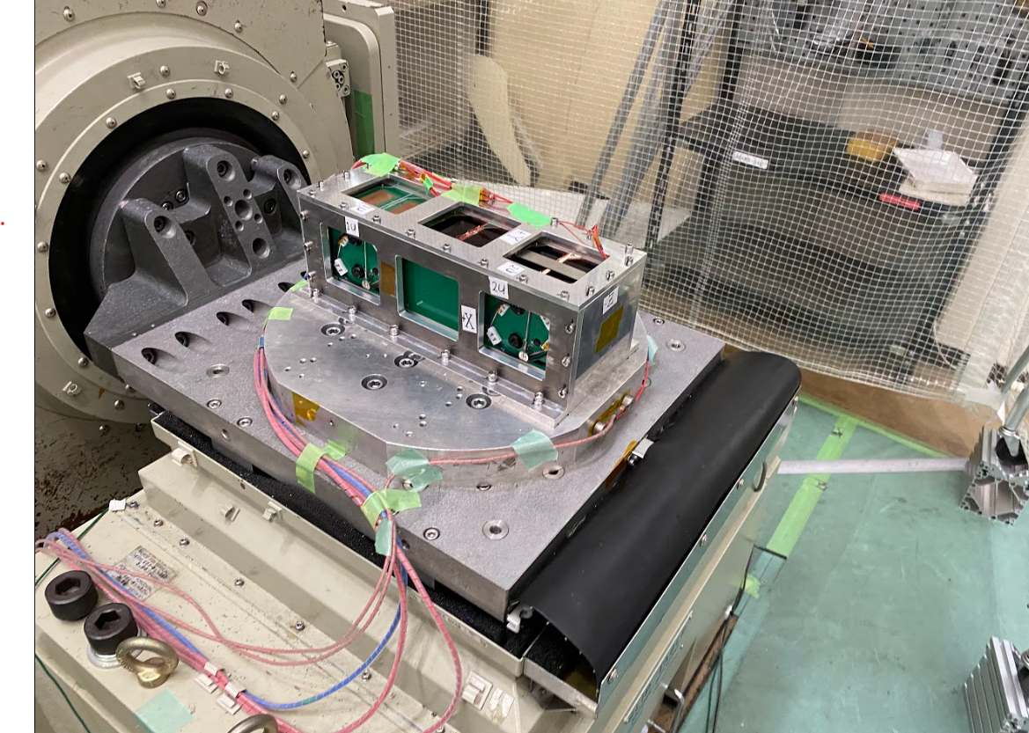

**Figure 3.4-2 Test architecture 1**

**Table 3.4-1. Table shows the settings on the PC for control and measurement of data.**

|  |  |  |  |  |
| --- | --- | --- | --- | --- |
| **Vibration test type** | | **Modal survey** | **Sine burst** | **Random** |
| Vibration Profile | | Random | Sine | Random |
| Vibration parameters | Test type | Modal | Sine Burst | Random |
|  | Frequency band [Hz]:  Min [Hz] | 20 | 5 | 20 |
|  | Frequency band [Hz]:  Max [Hz] | 2000 | 100 | 2000 |
|  | Setting of measuring:  Number of channels | 12 | 12 | 12 |
|  | Setting of measuring:  Measuring time [sec] | 50 | 40 | 110 |
|  | Setting of measuring:  Sampling rate [sample/sec] | 10,000 | 5,000 | 10,000 |
|  | Setting of analysis:  Number of FFT point | 16,384 | 4096 | 16,384 |
|  | Setting of analysis:  G/V | 31.6 | 31.6 | 31.6 |
| Monitor (OSC)  Display time (Sec) | Monitor (OSC)  Display time (Sec) | 0.2 | 0.2 | 0.2 |
| Monitor (OSC)  Max value of voltage (V) | Monitor (OSC)  Max value of voltage (V) | 0.5 | 7 | 4 |
| Vibration Machine control | Switch:  Sine - Random | Random | Sine/Shock | Random |
| External level | Half | Max | Max |
| AMP | G/V range of single sensor | 3.16 | 3.16 | 3.16 |
| G/V range of control sensor | 31.6 | 31.6 | 31.6 |

# 

# Test Schedule

**Table 4-1 Test Schedule**

|  |  |
| --- | --- |
| **Date** | **Task** |
| 2021/10/13 | Functional Test |
| 2021/10/13 | Preparation of Vibration test |
| 2021/10/14 | Y axis Vibration |
| 2021/10/14 | Z axis Vibration |
| 2021/10/14 | Change the vibration test machine axis |
| 2021/10/15 | X axis Vibration |
| 2021/10/15 | Clean up |
| 2021/10/15 | Functional Test |

# Organization

Test organization is shown in Figure 5-1.

|  |
| --- |
| **Test Responsible Person** |
| Masui sensei |
|  |
|  |
| **Test Leader** |
| Yamauchi |
|  |
|  |
| **Test Crew** |
| Victor  Oshiro |

**Figure5-1 Test organization**

# **Precaution**

## Precaution during test

1. Test was performed by the instruction of the test leader.
2. The measurement instrument was used within the time required calibration.

## Safety Control Matters

1. To wear steel-toed shoes during testing.
2. Don’t enter in the excitation direction during testing.

# Emergency Contact System

In case of emergency, the chain of commands was shown in Figure 7-1.



**Figure7-1 Emergency Contact System**

# Test Result 1U

Table 5-1 shows the as-run detailed procedural checklist and comments for each vibrations test step.

**Table 8-1 As-run detailed procedural checklist**

|  |  |  |  |  |  |  |  |  |
| --- | --- | --- | --- | --- | --- | --- | --- | --- |
| Ta+E38+A1:A1:H35 | Axis | Test | Torque marks | Picture | Test parameters | Accelero- | Test criteria No. | Comments |
| /Video | meter |
| 1 | - | Function test | ✔︎ | ✔︎ | - | ✔︎ | 1:pass | - |
| 2 | Y | Setup |  |  |  |  | 2: pass | - |
| 3: pass |
| 3 | Y | Modal | - | - | 0.5 Grms, 60 sec | - | 4: pass | Natural frequency: |
| 600Hz |
| 4 | Y | Random QT | ✔︎ | ✔︎ | 6.8Grms, | ✔︎ | 5: pass | - |
| 120sec |
| 5 | Y | Modal | - | - | 0.5 Grms, 60 sec | - | 4: pass | Natural frequency: |
| 5: pass | 584Hz, |
|  | 2.6% change |
| 6 | Y | Sin burst | ✔︎ | ✔︎ | 11.25G | ✔︎ | 4: pass | - |
| 20sec |
| 7 |  | Modal | - | - | 0.5 Grms, 60 sec | - | 5: pass | Natural frequency: 576Hz, |
| 1.3% change |
| 8 | Z |  |  |  |  |  |  |  |
| 9 | Z | Setup | - | - | - | - | 2: pass | - |
| 3: pass |
| 10 | Z | Modal | - | - | 0.5 Grms, 60 sec | - | 4: pass | Natural frequency: |
| 835Hz |
| 11 | Z | Random QT | ✔︎ | ✔︎ | 5.77Grms, | ✔︎ | 5: pass | - |
| 120sec |
| 12 |  |  |  |  |  |  |  |  |
| 13 | Z | Modal | - | - | 0.5 Grms, 60 sec | - | 4: pass | Natural frequency: |
| 5: pass | 809Hz, |
|  | 3.1% change |
| 14 |  | Sin burst | ✔︎ | ✔︎ | 11.3G | ✔︎ | 4: pass | - |
|  |
| 15 | Z | Modal | - | - | 0.5 Grms, 60 sec | - | 5: pass | Natural frequency: |  |
| 805Hz, |  |
| 0.8% change |  |
| 16 | X |  |  |  |  |  |  |  |  |
| 17 | X | Setup | - | - | - | - | 2: pass | - |  |
| 3: pass |  |
| 18 | X | Modal | - | - | 0.5 Grms, 60 sec | - | 4: pass | Natural frequency: |  |
| 409Hz |  |
| 19 | X | Random QT | ✔︎ | ✔︎ | 6.8Grms, | ✔︎ | 5: pass | - |  |
| 120sec |  |
| 20 | X | Modal | - | - | 0.5 Grms, 60 sec | - | 4: pass | Natural frequency: |  |
| 5: pass | 398Hz, |  |
|  | 2.7% change |  |
| 21 | X | Sin burst | ✔︎ | ✔︎ | 11.3G | ✔︎ | 4: pass | - |  |
|  |
| 22 | X | Modal | - | - | 0.5 Grms, 60 sec | - | 5: pass | Natural frequency: |  |
| 409Hz, |  |
| 2.7% change |  |
| 23 | - | Open total for check | - | - | - | - | 1:pass | All torques good. |  |
| String do not cut and loose. |  |
| 24 | - | - | - | - | - | - | - | - |  |

## **8.1 Visual inspection**

The visual inspection for the satellite was conducted before/after the test. And no breakage was found in the satellite after the test. Also, there was no breakage in the solar cell cover glass, camera lens and protective tempered glass. There was no improper antenna deployment during and after the vibration. However, loosening was found in all fasteners. And malfunction occurred to CubeSat, either. Test results show in Table 8.1-1 and Figure 8.1-1 to Figure 8.1-6.

Table 8.1-1 Inspection Result

|  |  |  |  |
| --- | --- | --- | --- |
|  | Part Name | Quantity | Inspection Result |
| 1 | BIRDS 5 EM | 1 | Pass |
| 1-1 | Camera filters | 2 | Pass |
| 1-2 | Camera lens | 3 | Pass |
| 1-3 | Torque mark | - | Pass |
| 1-4 | Antenna mechanism | 4 | Pass |

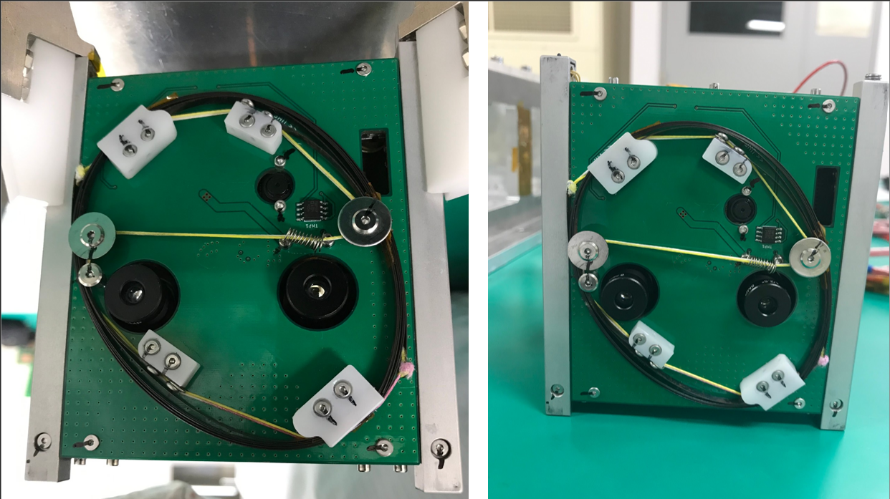

Figure 8.1-1 Photo on the +X surface (Left: before test Right: after test)

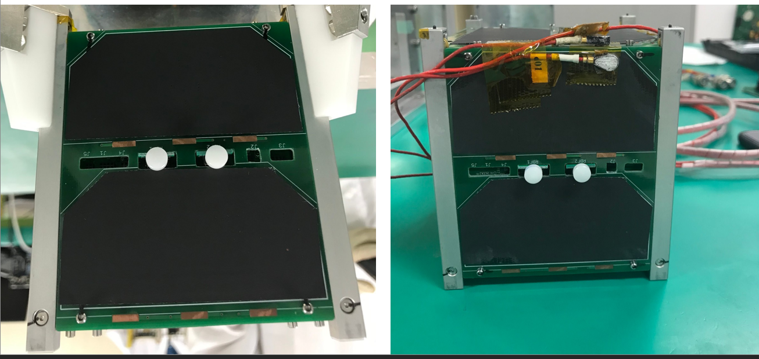

Figure 8.1-2 Photo on the -X surface (Left: before test Right: after test)

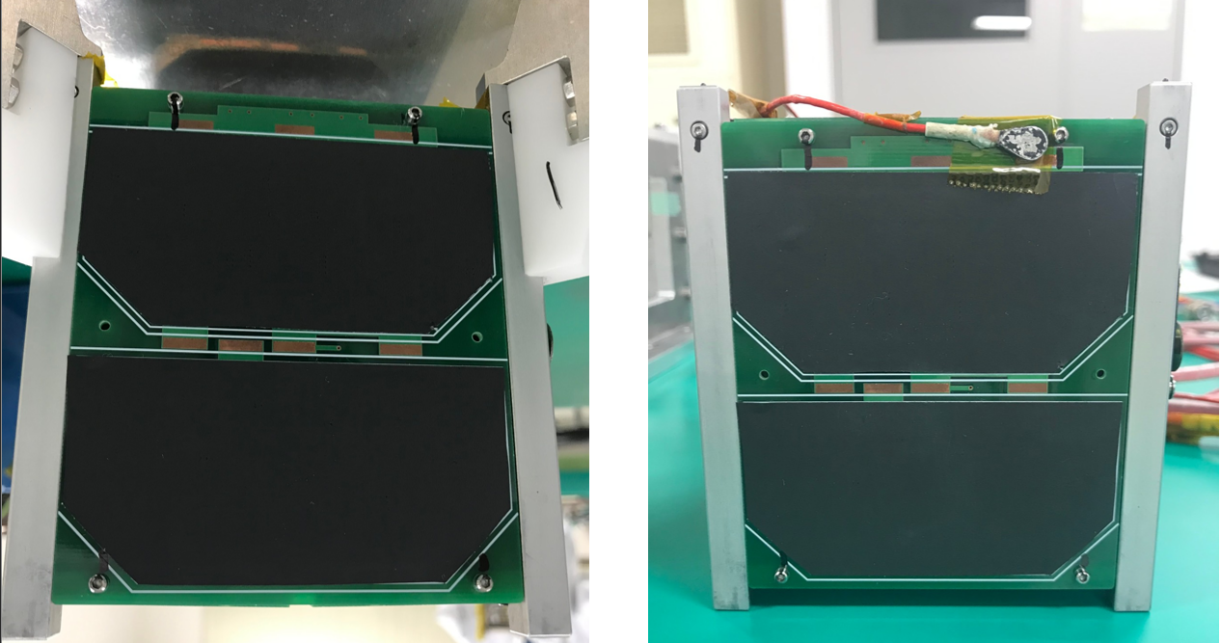

Figure 8.1-3 Photo on the +Y surface (Left: before test Right: after test)

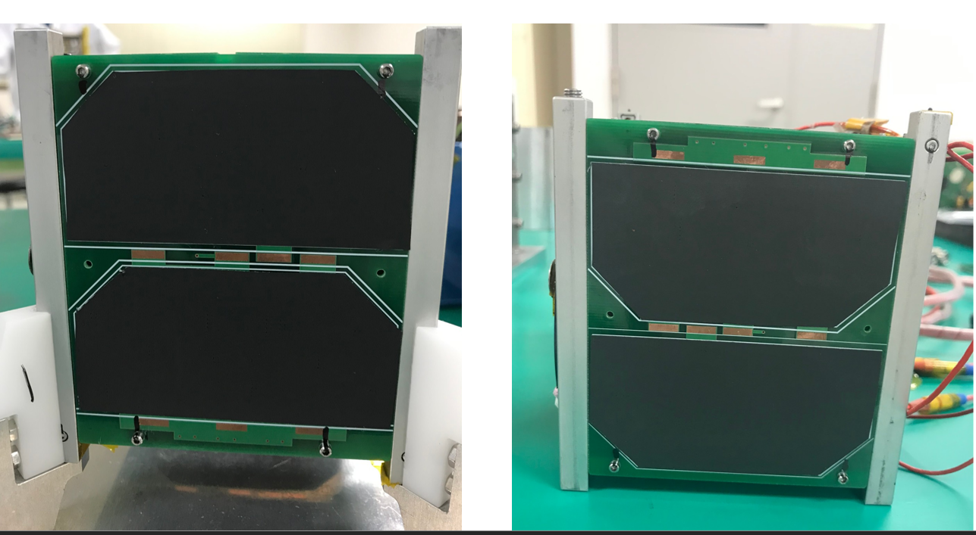

Figure 8.1-4 Photo on the -Y surface (Left: before test Right: after test)

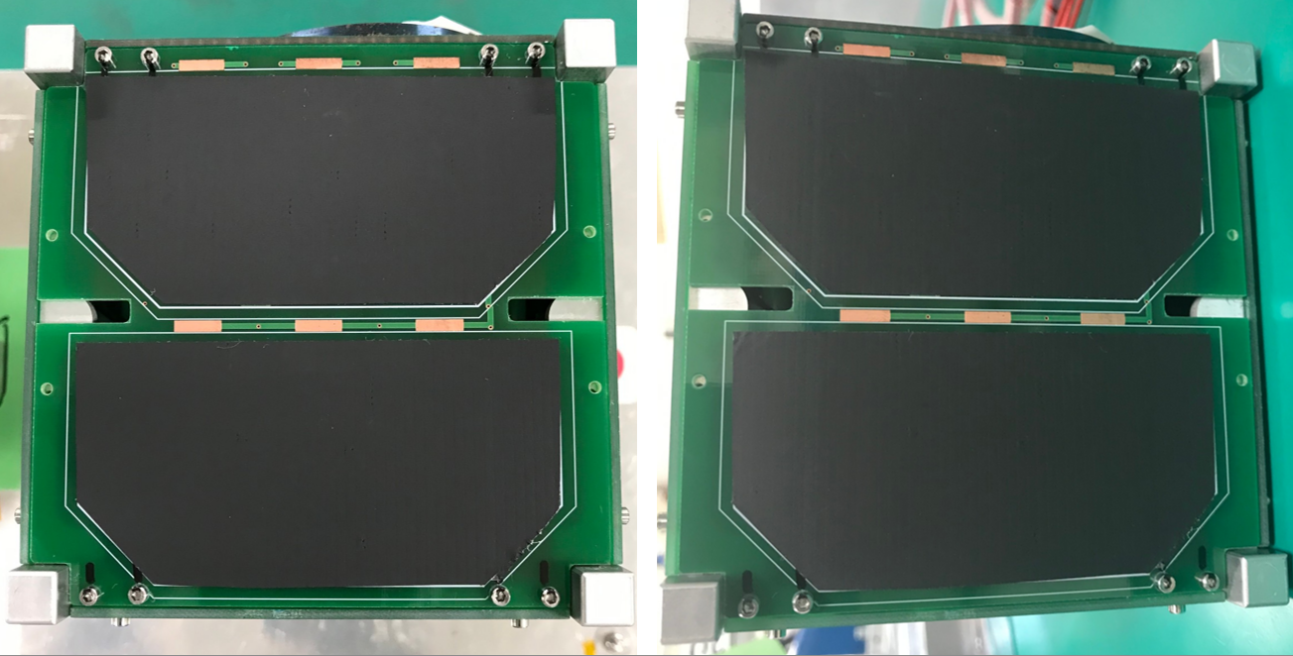

Figure 8.1-5 Photo on the +Z surface (Left: before test Right: after test)

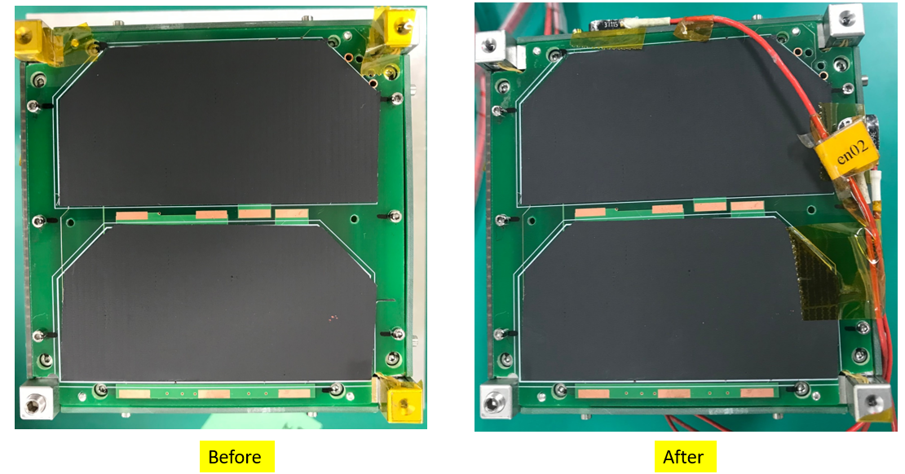

Figure 8.1-6 Photo on the -Z surface (Left: before test Right: after test)

## **Random Vibration Test**

### **X-axis vibration**

Acceleration at control sensor resulted to be met requirement of vibration level. Also, acceleration data measured by modal survey before/after random vibration and sine burst are same. Test results show in Figure 8.2.1-1 to Figure 8.2.1-5.

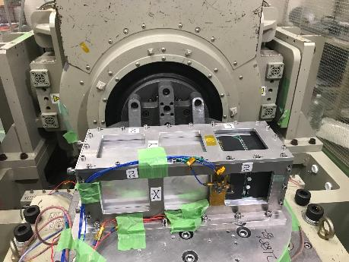

Figure 8.2.1-1　X-axis Test Configuration with Satellite

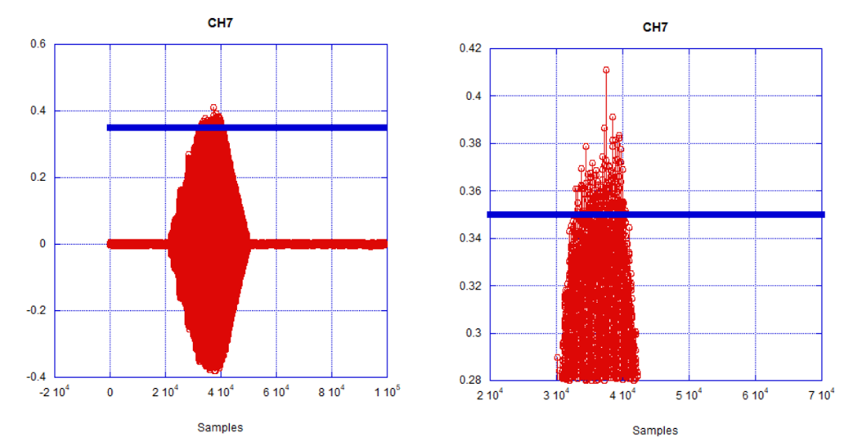

Figure 8.2.1-2 X-axis Sine burst wave at measurement sensor

Figure 8.2.1-3 X-axis PSD of Random vibration at control sensor

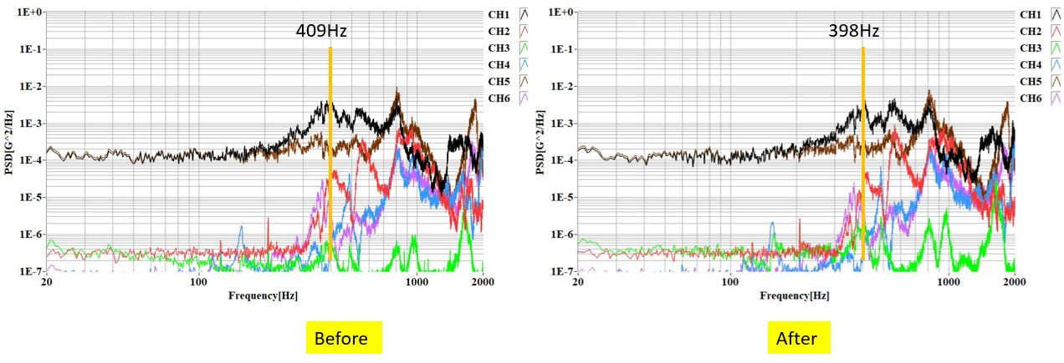

Figure 8.2.1-4　Modal Survey before and after sineburst X-axis at Mesurement Point

(Left: before, Right: after)

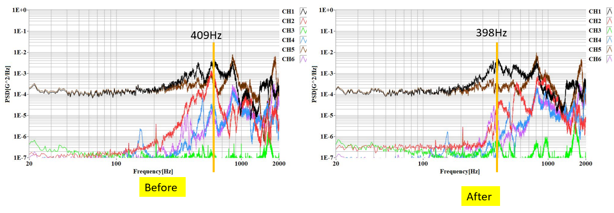

Figure 8.2.1-5　Modal Survey before and after random vibrating X-axis at Mesurement Point

(Left: before, Right: after)

### **Y-axis vibration**

Acceleration at control sensor resulted to be met requirement of vibration level. Also, acceleration data measured by modal survey before/after random vibration are same. Test results show in Figure 8.2.2-1 to Figure 8.2.2-5.

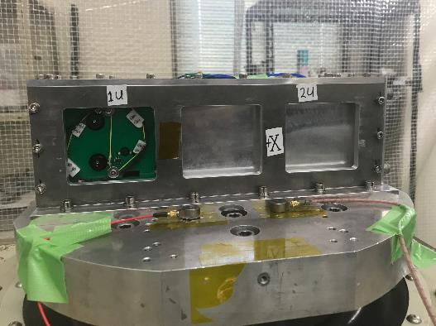

Figure 8.2.2-1　Y-axis Test Configuration with Test Jig only

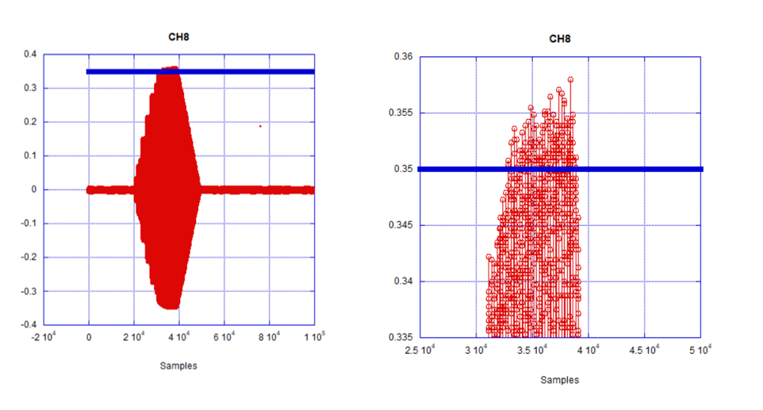

Figure 8.2.2-3 Y-axis Sine burst wave at measurement sensor

Figure 8.2.2-2　Y-axis PSD of Random vibration at control

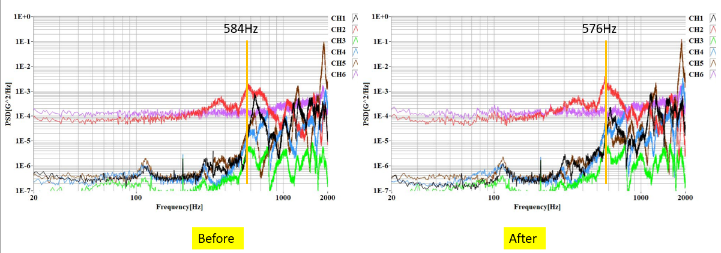

Figure 8.2.2-4　Modal Survey before and after sineburst Y-axis at Mesurement Point

(Left: before, Right: after)

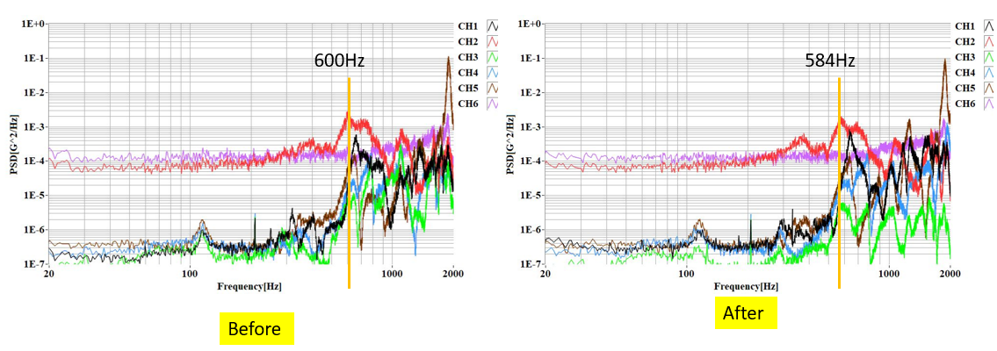

Figure 8.2.2-5　Modal Survey before and after random vibrating Y-axis at Mesurement Point

(Left: before, Right: after)

### **Z-axis vibration**

Acceleration at control sensor resulted to be met requirement of vibration level. Also, acceleration data measured by modal survey before/after random vibration are same. Test results show in Figure 8.2.3-1 to Figure 8.2.3-5.

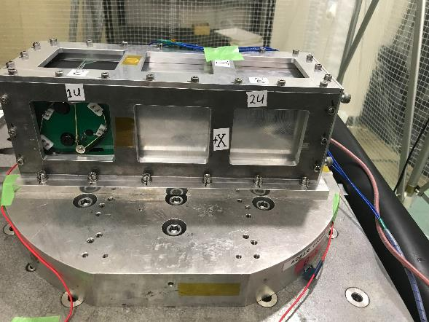

Figure 8.2.3-1　Z-axis Test Configuration with Satellite

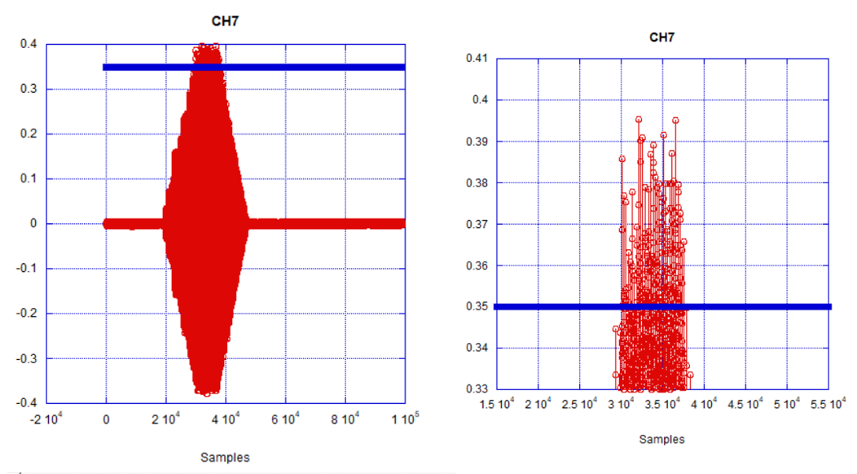

Figure 8.2.3-2 Z-axis Sine burst wave at measurement sensor

Figure 8.2.3-3　Z-axis PSD Random Vibration at Control Sensor

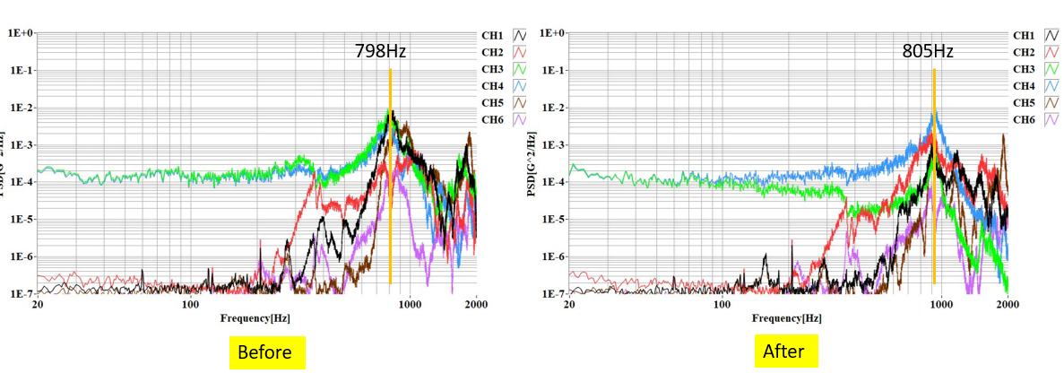

Figure 8.2.3-4　Modal Survey before and after Sine burst Z-axis at Mesurement Point

(Left: before, Right: after)

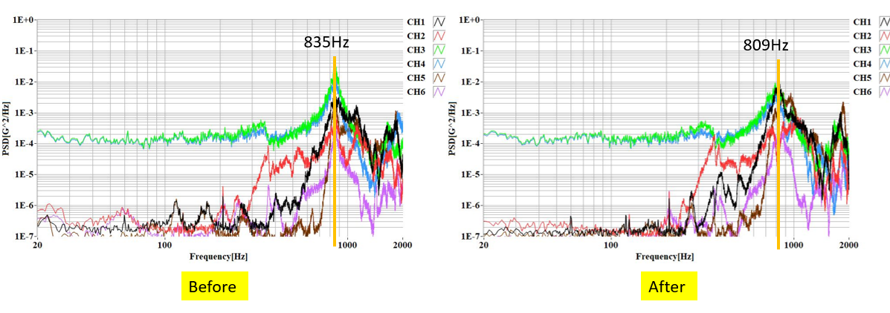

Figure 8.2.3-5　Modal Survey before and after random vibrating Z-axis at Mesurement Point

(Left: before, Right: after)

# Function Test

There was no failure or abnormal status on the voltage of battery and health data of the OBC (On-Board Computer) after vibration test. The main bus and all missions for the BIRDS 5 1U EM were functioning before and after vibration testing.

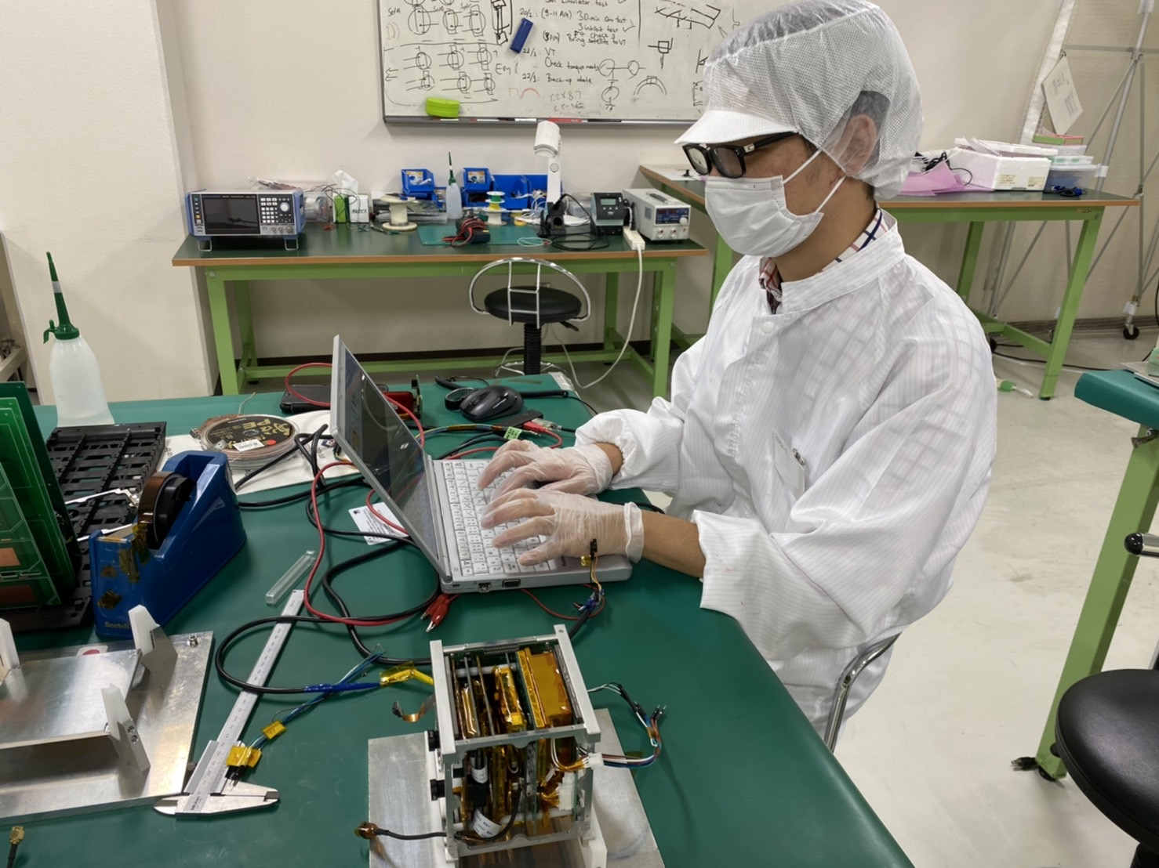

Figure 9.1-1　Function Test Configuration

# Test Result 2U

Table 5-1 shows the as-run detailed procedural checklist and comments for each vibrations test step.

**Table 8-1 As-run detailed procedural checklist for BIRD5 2U Satellite**

|  |  |  |  |  |  |  |  |  |
| --- | --- | --- | --- | --- | --- | --- | --- | --- |
| Task No. | Axis | Test | Torque marks | Picture  /Video | Test parameters | Accelero-  meter | Test criteria No. | Comments |
| 01 | - | Function test | ✔︎ | ✔︎ | - | ✔︎ | 1:pass | - |
| 02 | Y | Setup |  |  |  |  | 2: pass  3: pass | - |
| 03 | Y | Modal | - | - | 0.5 Grms, 60 sec | - | 4: pass | Natural frequency:  405Hz |
| 04 | Y | Random QT | ✔︎ | ✔︎ | 6.8Grms,  120sec | ✔︎ | 5: pass | - |
| 05 | Y | Modal | - | - | 0.5 Grms, 60 sec | - | 4: pass  5: pass | Natural frequency:  368Hz,  9.1% change |
|  | Y | Sin burst | ✔︎ | ✔︎ | 11.25G  20sec | ✔︎ | 4: pass | - |
| 06 |  | Modal | - | - | 0.5 Grms, 60 sec | - | 5: pass | Natural frequency: 365Hz,  1.6% change |
| 07 | X |  |  |  |  |  |  |  |
| 08 | X | Setup | - | - | - | - | 2: pass  3: pass | - |
| 09 | X | Modal | - | - | 0.5 Grms, 60 sec | - | 4: pass | Natural frequency:  315Hz |
| 10 | X | Random QT | ✔︎ | ✔︎ | 6.8Grms,  120sec | ✔︎ | 5: pass | - |
| 11 | X | Modal | - | - | 0.5 Grms, 60 sec | - | 4: pass  5: pass | Natural frequency:  314Hz,  0.3% change |
|  | X | Sin burst | ✔︎ | ✔︎ | 11.3G | ✔︎ | 4: pass | - |
| 12 | X | Modal | - | - | 0.5 Grms, 60 sec | - | 5: pass | Natural frequency:  316Hz,  0.64% change |
| 13 | Z |  |  |  |  |  |  |  |
| 14 | Z | Setup | - | - | - | - | 2: pass  3: pass | - |
| 15 | Z | Modal | - | - | 0.5 Grms, 60 sec | - | 4: pass | Natural frequency:  805Hz |
|  | Z | Random QT | ✔︎ | ✔︎ | 5.77Grms,  120sec | ✔︎ | 5: pass | - |
| 16 |  |  |  |  |  |  |  |  |
| 17 | Z | Modal | - | - | 0.5 Grms, 60 sec | - | 4: pass  5: pass | Natural frequency:  813Hz,  0.99% change |
| 18 |  | Sin burst | ✔︎ | ✔︎ | 11.3G | ✔︎ | 4: pass | - |
| 19 | Z | Modal | - | - | 0.5 Grms, 60 sec | - | 5: pass | Natural frequency:  809Hz,  0.5% change |
| 20 | - | Open total for check | - | - | - | - | 1:pass | All torques good.  String do not cut and loose. |
| 21 | - | - | - | - | - | - | - | - |

## **8.1 Visual inspection**

The visual inspection for the satellite was conducted before/after the test. And no breakage was found in the satellite after the test. Also, there was no breakage in the solar cell cover glass, camera lens and protective tempered glass. There was no improper antenna deployment during and after the vibration. However, loosening was found in all fasteners. And malfunction occurred to CubeSat, either. Test results show in Table 8.1-1 and Figure 8.1-1 to Figure 8.1-6.

Table 8.1-1 Inspection Result

|  |  |  |  |
| --- | --- | --- | --- |
|  | Part Name | Quantity | Inspection Result |
| 1 | BIRDS 5 EM | 1 | Pass |
| 1-1 | Solar panel cover grass | 4 | Pass |
| 1-2 | Camera lens | 3 | Pass |
| 1-3 | Torque mark | - | Pass |
| 1-4 | Antenna mechanism | 4 | Pass |
| 1-5 | Antenna PCB | 1 | Fail |
| 1-6 | DLP mechanism | 1 | Fail |
| 1-7 | Camera filter | 2 | Pass |

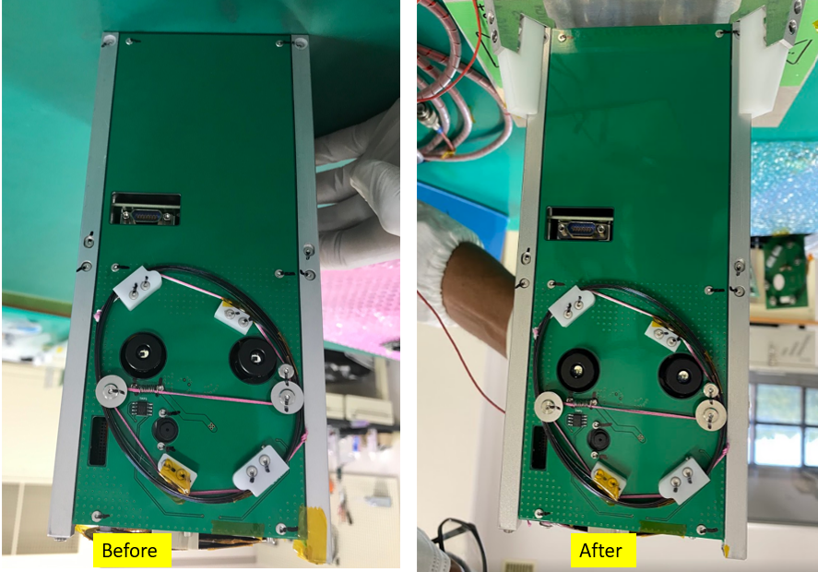

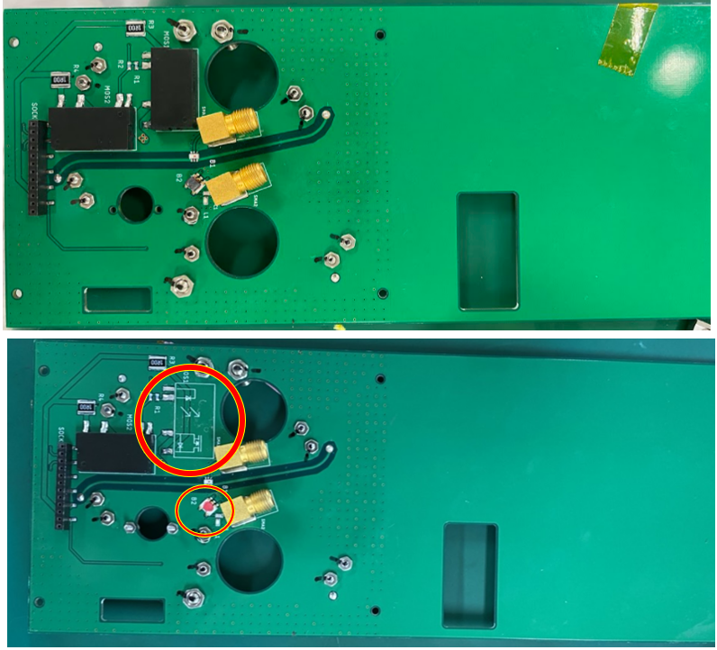

Figure 8.1-1 Photo on the +X surface (Left: before test Right: after test)

The mosphet and balun were removed during vibration and was observed on the visual inspection.

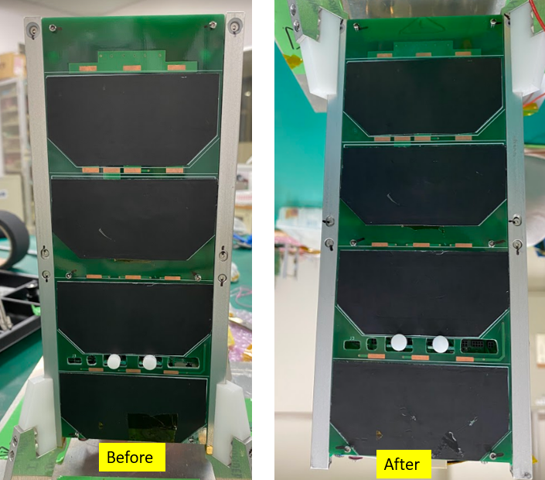

Figure 8.1-2 Photo on the -X surface (Left: before test Right: after test)

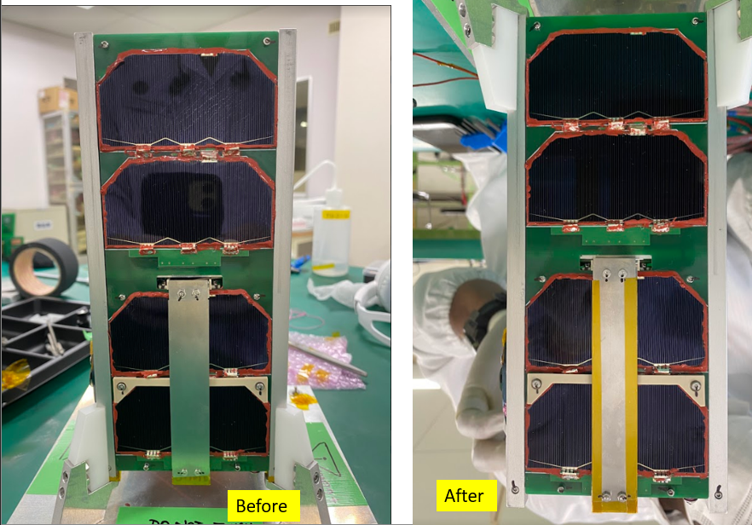

Figure 8.1-3 Photo on the +Y surface (Left: before test Right: after test)

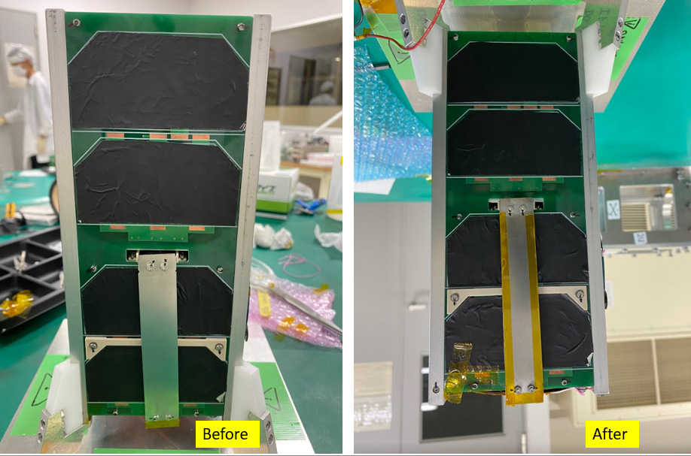

Figure 8.1-4 Photo on the -Y surface (Left: before test Right: after test)

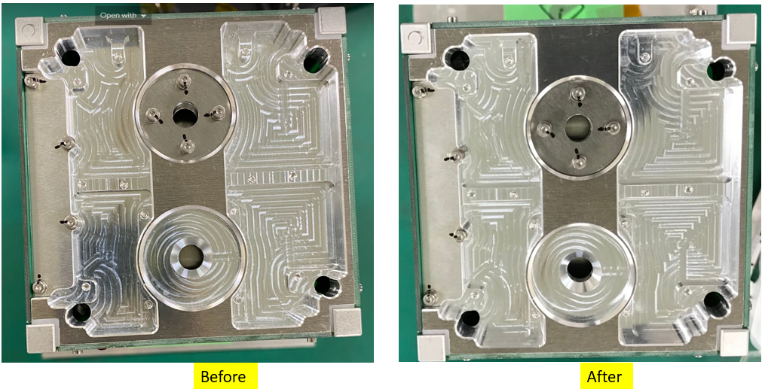

Figure 8.1-5 Photo on the +Z surface (Left: before test Right: after test)

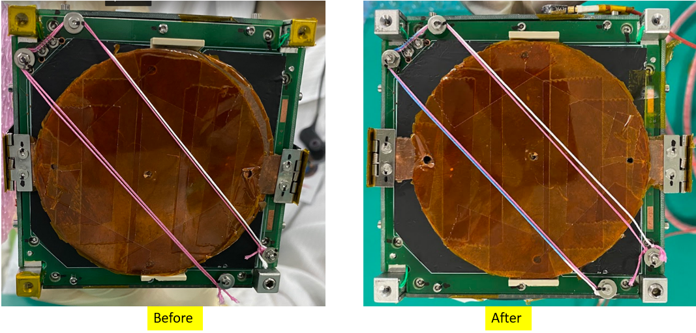

Figure 8.1-6 Photo on the -Z surface (Left: before test Right: after test)

## **Random Vibration Test**

### **X-axis vibration**

Acceleration at control sensor resulted to be met requirement of vibration level. Also, acceleration data measured by modal survey before/after random vibration and sine burst are same. Test results show in Figure 8.2.1-1 to Figure 8.2.1

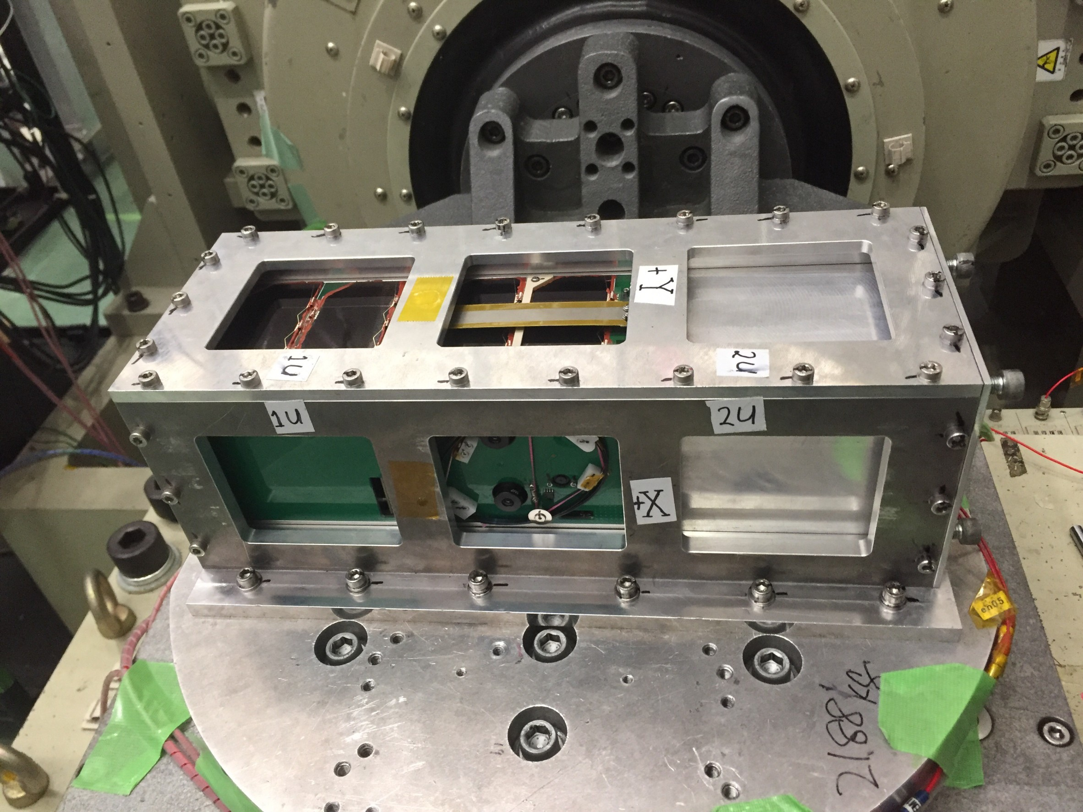

Figure 8.2.1-1　X-axis Test Configuration with Satellite

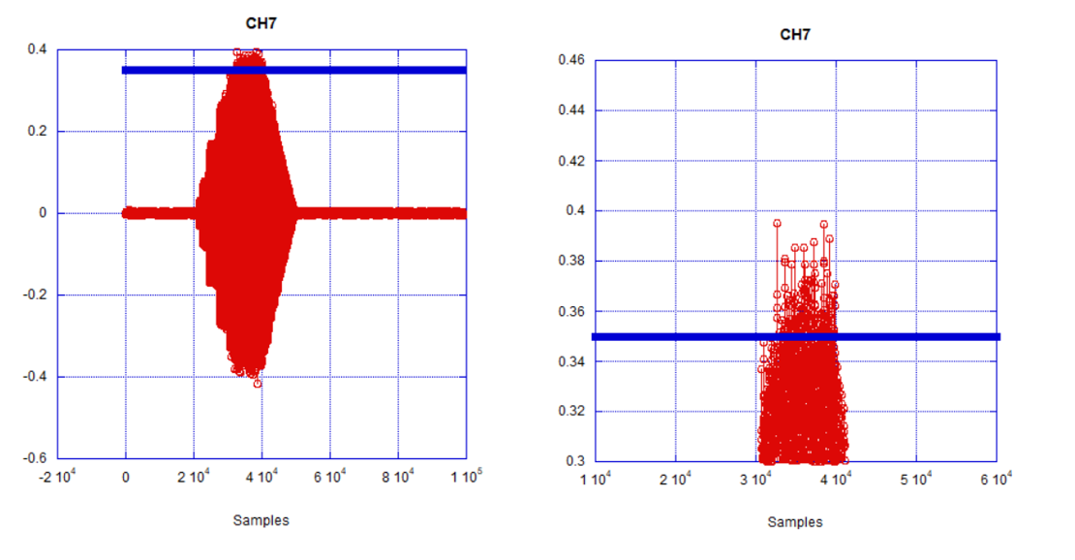

Figure 8.2.1-2 X-axis Sine burst wave at measurement sensor

Figure 8.2.1-3 X-axis PSD of Random vibration at control sensor

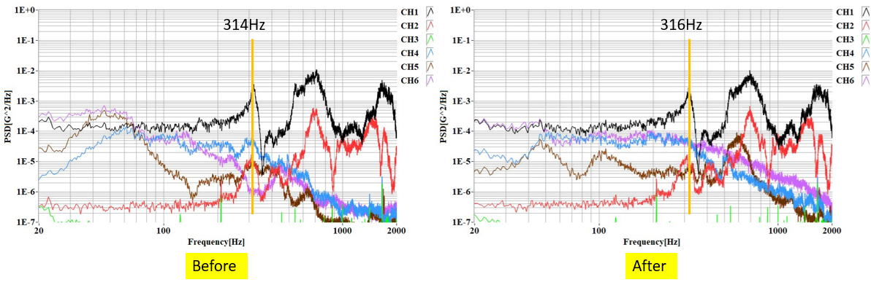

Figure 8.2.1-4　Modal Survey before and after sineburst X-axis at Mesurement Point

(Left: before, Right: after)

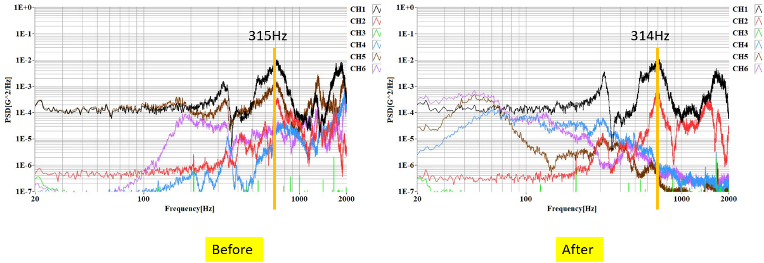

Figure 8.2.1-5　Modal Survey before and after random vibrating X-axis at Mesurement Point

(Left: before, Right: after)

### **Y-axis vibration**

Acceleration at control sensor resulted to be met requirement of vibration level. Also, acceleration data measured by modal survey before/after random vibration are same. Test results show in Figure 8.2.2-1 to Figure 8.2.2-5.

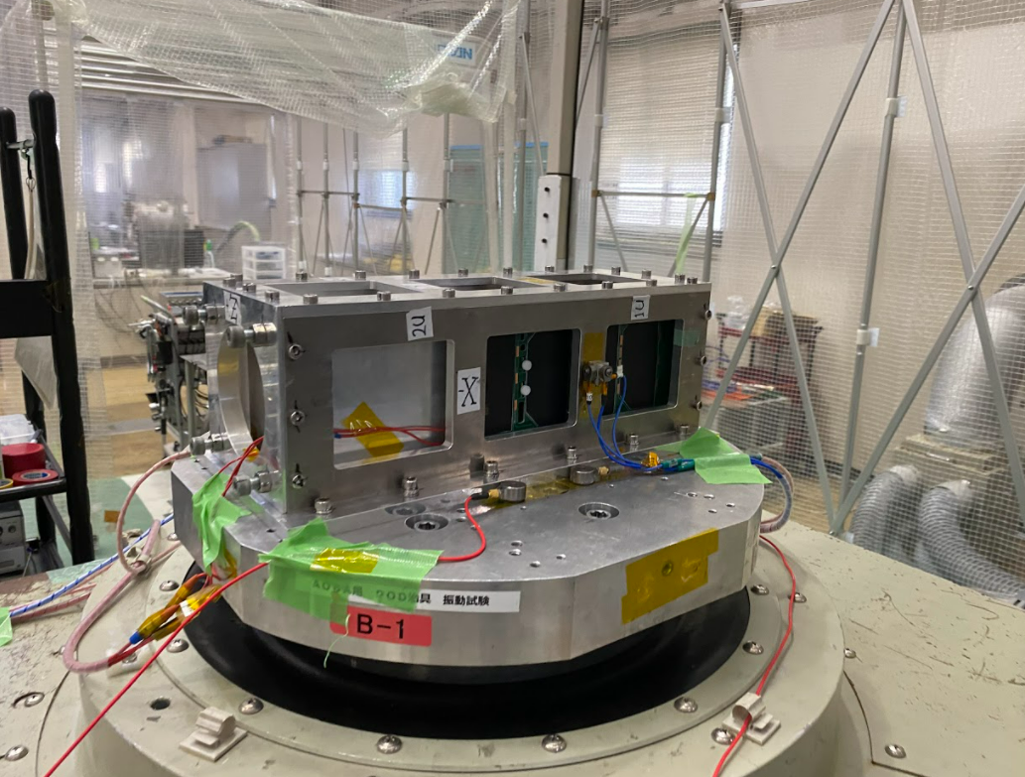

Figure 8.2.2-1　 Y-axis Test Configuration with Test Jig only

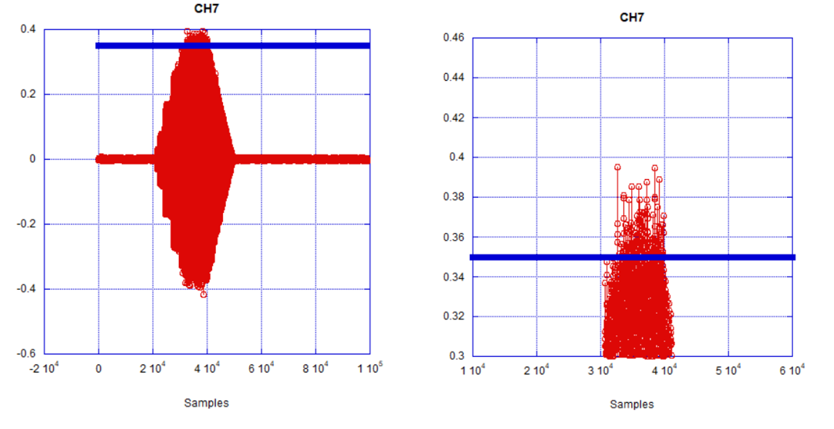

Figure 8.2.2-3 Y-axis Sine burst wave at measurement sensor

Figure 8.2.2-2　Y-axis PSD of Random vibration at control

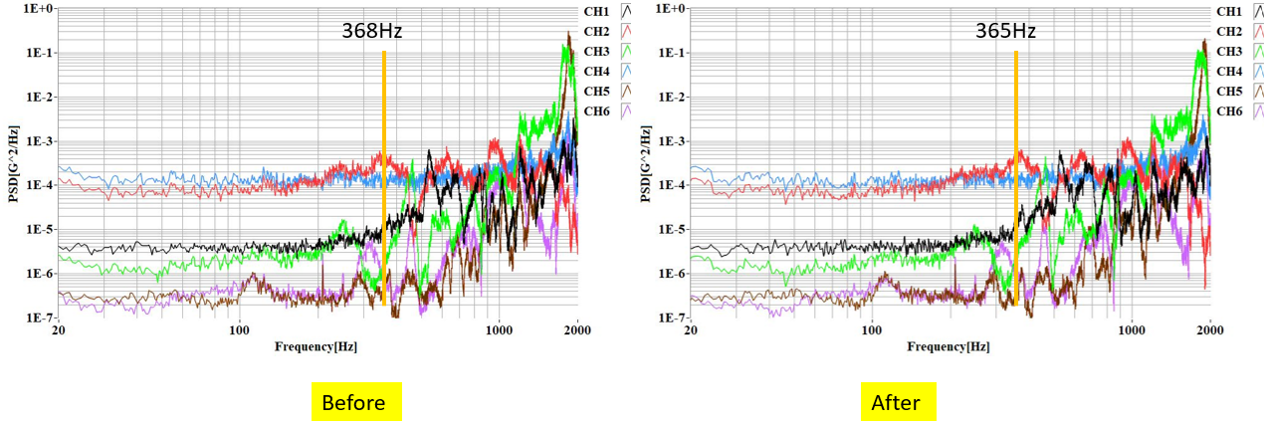

Figure 8.2.2-4　Modal Survey before and after sineburst Y-axis at Mesurement Point

(Left: before, Right: after)

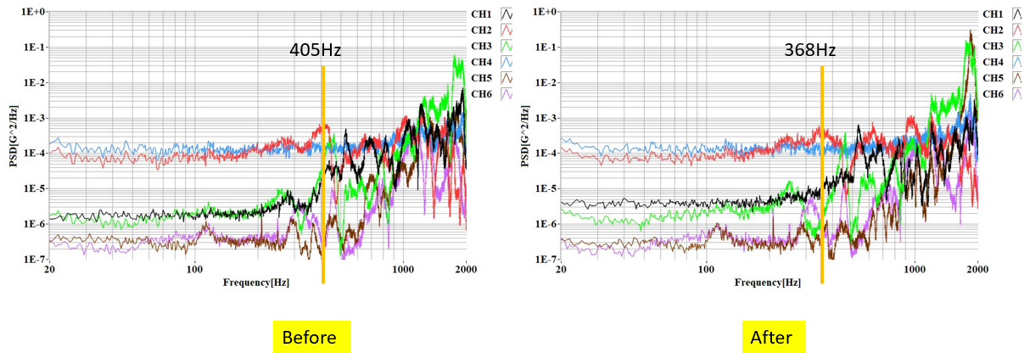

Figure 8.2.2-5　Modal Survey before and after random vibrating Y-axis at Mesurement Point (Left: before, Right: after)

### **Z-axis vibration**

Acceleration at control sensor resulted to be met requirement of vibration level. Also, acceleration data measured by modal survey before/after random vibration are same. Test results show in Figure 8.2.3-1 to Figure 8.2.3-5.

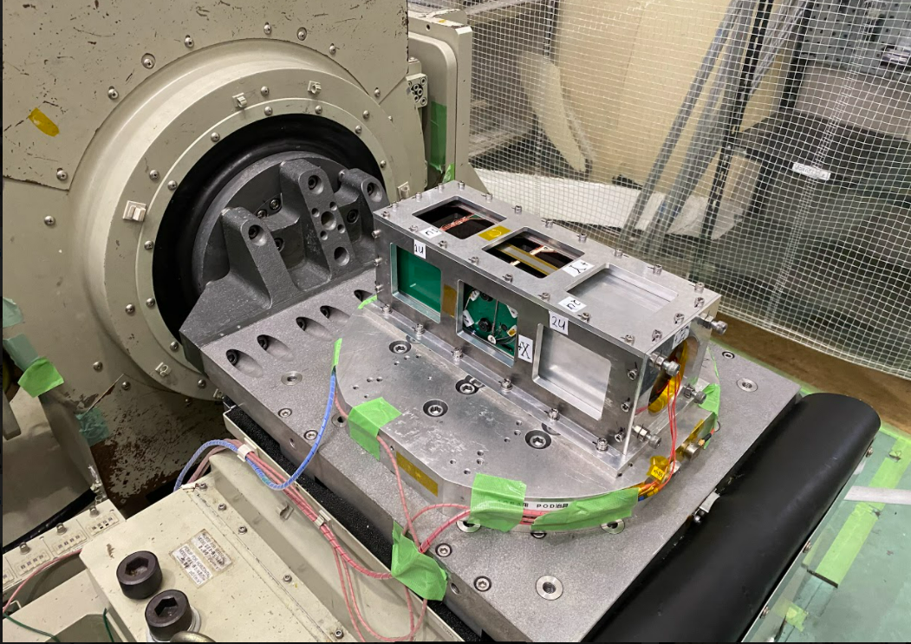

Figure 8.2.3-1　Z-axis Test Configuration with Satellite

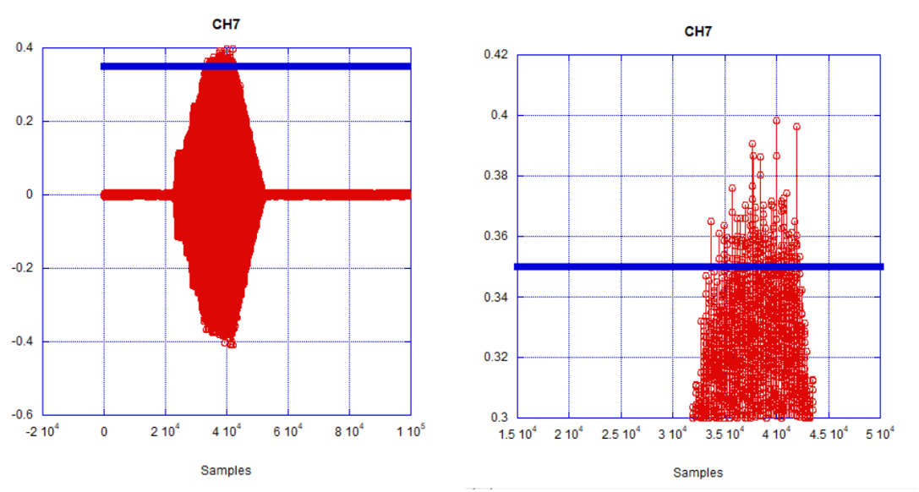

Figure 8.2.3-2 Z-axis Sine burst wave at measurement sensor

Figure 8.2.3-3　Z-axis PSD Random Vibration at Control Sensor

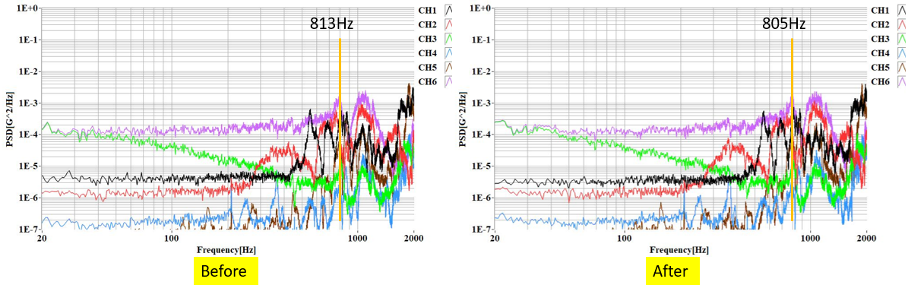

Figure 8.2.3-4　Modal Survey before and after Sine burst Z-axis at Mesurement Point

(Left: before, Right: after)

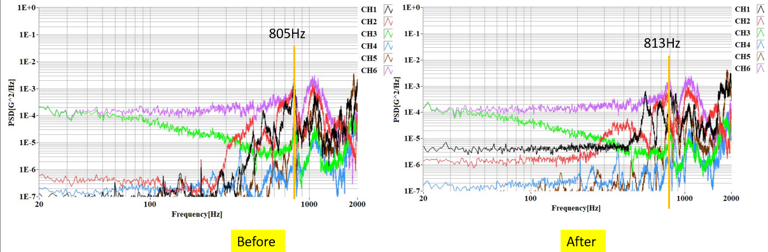

Figure 8.2.3-5　Modal Survey before and after random vibrating Z-axis at Mesurement Point

(Left: before, Right: after)

# 9 Function Test

There was no failure or abnormal status on the voltage of battery and health data of the OBC (On-Board Computer) after vibration test. However, some internal boards were found to be damaged or malfunctioning. The satellite had damage from vibration environment.



Figure 9.1-1　Function Test Configuration

# Observation

10.1 Visual Inspection

10.2 Summary of findings

10.2-1 Main bus:

* 1. Inspection findings

10.3-1 Deformation and Damaged Inspection

10.3-3 Shatter able items Inspection

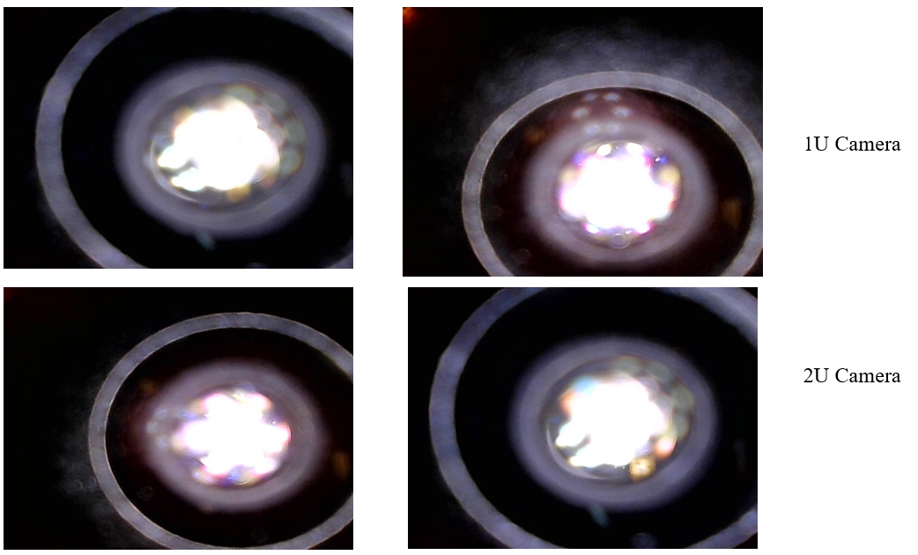

Figure 9.3-4a Camera lens and filter

The camera filters and lens were not damaged after vibration.



Figure 9.3-4b Solar cells &

The solar cells where intact and no visible damage was observed after the vibration test.

10.3-4 DLP deployment

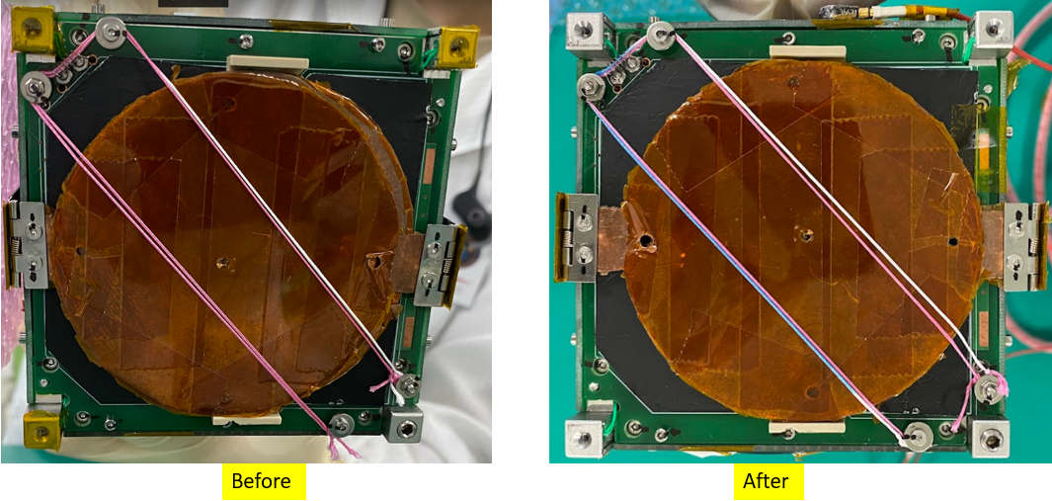  
Figure 10.3-5 Antenna deployment

9mm

Remarks:

The DLP slightly opened outside the envelope to a total protrusion of 9mm from the panel.

10.3-5 Antenna Harness string Inspection

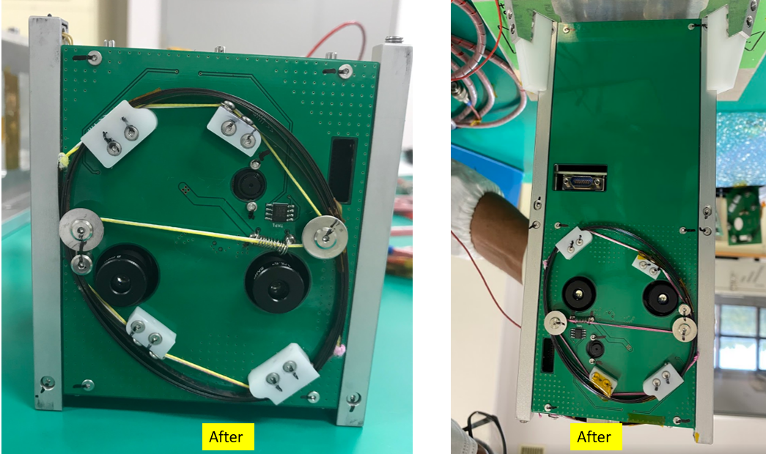

Figure 10.3-6 Antenna Harness string

Remarks: Folded antenna was released during vibration.   All other antenna harnesses (strings) were secure and no damage or untangling to the strings.

# Conclusion

No distortion or damage were found on BIRDS 5 1U satellite and on the solar cell by visual inspection after the vibration. There were no loosening of screws both internally and externally after inspecting the torque marks. Moreover, no breakage of the solar cell cover grass and camera lens were found based on visual inspection after the vibration. The observed damages were observed on the antenna mosphet and balun which will be glue with RTV in FM stage.